**GRAPHIC DESIGN ASSIGNMENT**

**GOOD DESIGN**

1.

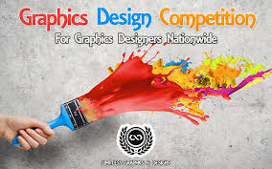

**Reasons;**

1. The blending of colors makes it more appealing to the eye.
2. It is simple to understand the message being passed on.
3. The many colors splashed by the brush shows the different fields of graphic design.

2.



**Reasons;**

1. It has a catchy headline (outstanding)

2. The blending of colors makes it more attractive.

3. The design brings out sense of fun brought by the product.

31.



1. It is easy to understand what is being advertised.

2. The colors are pleasing and attracting.

3. The image used makes it so real.

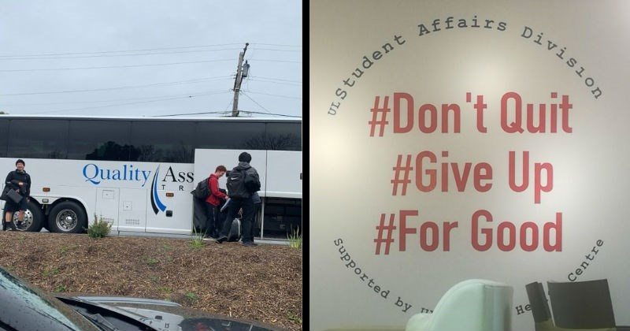

**BAD DESIGN**

**1**. The message is not clear.

2. Some information has been blocked

3. The blocked information on the bus is bringing out a different interpretation.

2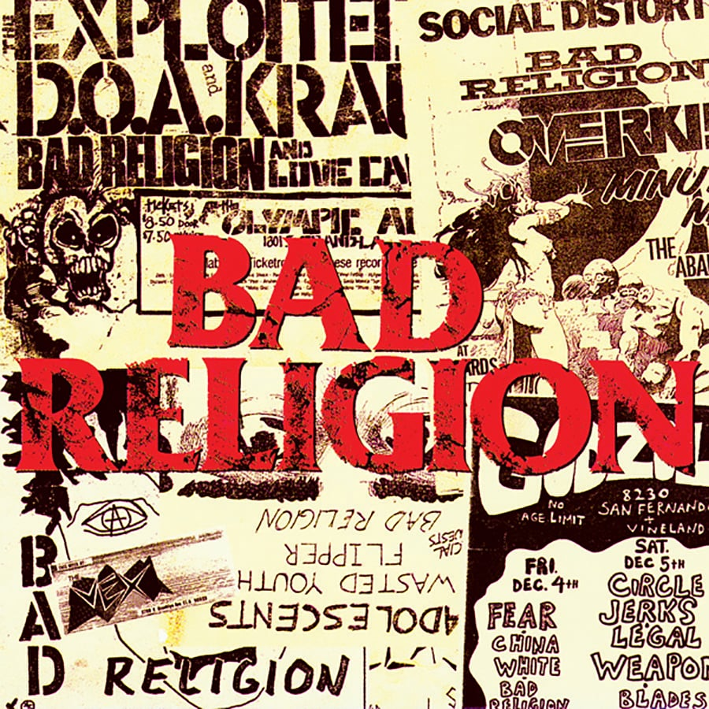

1. The colors used are not blending.

2. The fonts used are mismatching.

3. Poor clarit ;some information are hidden by the bolded words.

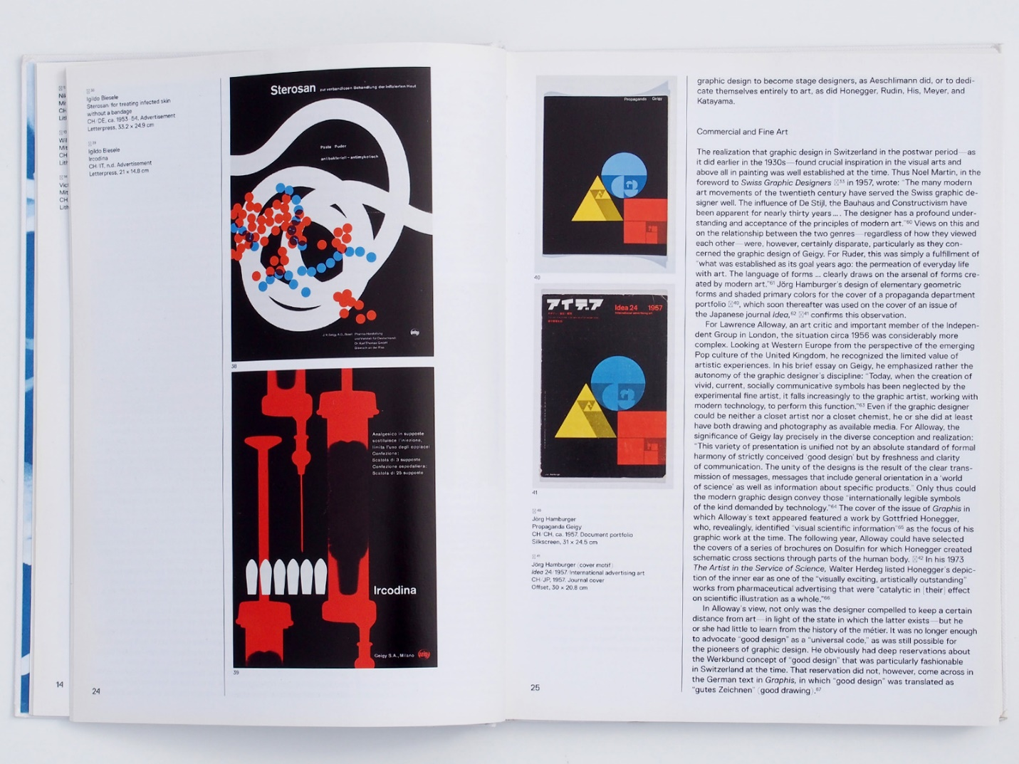

1. The information used is too much making it boring to read.

2. The font used is invisible making it hard for the reader to read.

3. Whatever is being advertised is not clear.

`